Intelligent Water Leakage Prediction and Consumption Anomaly Detection Using Machine Learning
Aim of the Experiment
To develop an intelligent water leakage prediction and consumption anomaly detection system using Machine Learning techniques. The system uses a Random Forest Regressor to predict expected water consumption and an Isolation Forest algorithm to identify unusual consumption patterns. A Flask-based web application displays actual consumption, predicted consumption, anomaly status, and warning messages to help users identify possible water leakage and reduce water wastage.

Problem Statement
Water leakage and unusual water consumption can lead to significant water wastage, increased utility bills, and damage to buildings. In many homes and small facilities, water usage is checked manually or only after a leak becomes visible. This can delay detection, especially when a pipe leaks slowly or consumption rises unexpectedly during periods when usage should be low.
Therefore, an intelligent system is needed to study water-consumption readings, predict expected usage, and identify abnormal patterns that may indicate leakage or unusual consumption. This project proposes a machine-learning-based monitoring system that accepts historical or sensor-based water readings, predicts expected consumption, detects anomalies, and displays alerts through a simple web interface. The system is intended as a decision-support tool; an anomaly is a warning for inspection and does not by itself prove that a leak exists.

Objectives
- To collect or load time-based water-consumption readings from a CSV dataset or meter/sensor.
- To clean the data and create useful time features such as hour, day, and previous consumption.
- To train a machine-learning model to estimate expected water consumption.
- To apply an anomaly-detection model to flag readings that differ significantly from normal usage.
- To provide a simple Flask-based web dashboard showing readings, predicted consumption, anomaly status, and suggested inspection alerts.
- To evaluate prediction performance using suitable regression metrics and review anomaly-detection results.
- To store readings and detection results for later review.

Software / Hardware Required
- Operating System: Windows / Linux / macOS
- IDE: Visual Studio Code or JupyterLab
- Programming Language: Python 3.x
- Data Processing: pandas, NumPy
- Machine Learning: scikit-learn (RandomForestRegressor and IsolationForest)
- Visualization: Matplotlib (optional)
- Web Framework: Flask
- Frontend: HTML5, CSS3, JavaScript
- Data Storage: CSV file or SQLite database
- Hardware (optional): water-flow sensor, microcontroller such as ESP32/Arduino, and a compatible water meter setup

Project Directory Structure
The project can be organized as a Python machine-learning module with a Flask web interface and a separate dataset folder.
WaterLeakageDetection/
├── app.py
├── train_model.py
├── data/
│ └── water_consumption.csv
├── models/
│ ├── consumption_model.pkl
│ └── anomaly_model.pkl
├── templates/
│ └── index.html
├── static/
│ └── style.css
└── requirements.txt
Fig. 1: Suggested directory structure for the Water Leakage Prediction and Anomaly Detection project.

Procedure
- Prepare a dataset containing timestamp and water-consumption readings. Readings may be collected from a meter/sensor or taken from a suitable sample CSV file.
- Inspect the dataset, remove duplicate or invalid records, handle missing values, and sort the readings by timestamp.
- Create features such as hour of day, day of week, and previous reading/usage. Use only information available at prediction time to avoid data leakage.
- Split the data into training and testing sets in chronological order, so later readings are used for testing.
- Train a Random Forest regression model to predict expected water consumption from the selected features.
- Train an Isolation Forest model on normal or predominantly normal consumption features to identify unusual patterns.
- Save the trained models using joblib so that the web application can load them later.
- Start the Flask application and open the dashboard in a browser.
- Enter or upload a water-consumption reading. The application prepares the features and obtains the predicted consumption and anomaly status.
- Compare the observed reading with the predicted value and display a warning when the reading is flagged as unusual.
- Evaluate the regression model using MAE and RMSE. Review flagged readings and adjust the model or threshold based on the quality of the available data.

Implementation Code
The following sample modules demonstrate the core machine-learning workflow. Column names must match the dataset used in the actual project. A sample dataset should contain at least timestamp and consumption columns.

1. Data preparation and model training (train_model.py)
import pandas as pd
import joblib
from sklearn.ensemble import RandomForestRegressor, IsolationForest
from sklearn.metrics import mean_absolute_error, mean_squared_error
from math import sqrt
# CSV columns: timestamp, consumption_liters
df = pd.read_csv("data/water_consumption.csv")
df["timestamp"] = pd.to_datetime(df["timestamp"], errors="coerce")
df["consumption_liters"] = pd.to_numeric(
df["consumption_liters"], errors="coerce"
)
df = df.dropna(subset=["timestamp", "consumption_liters"])
df = df.sort_values("timestamp").reset_index(drop=True)
df["hour"] = df["timestamp"].dt.hour
df["day_of_week"] = df["timestamp"].dt.dayofweek
df["previous_usage"] = df["consumption_liters"].shift(1)
df = df.dropna().reset_index(drop=True)
features = ["hour", "day_of_week", "previous_usage"]
X = df[features]
y = df["consumption_liters"]
# Chronological split: first 80% train, final 20% test
split = int(len(df) * 0.8)
X_train, X_test = X.iloc[:split], X.iloc[split:]
y_train, y_test = y.iloc[:split], y.iloc[split:]
regressor = RandomForestRegressor(
n_estimators=100, random_state=42
)
regressor.fit(X_train, y_train)
predictions = regressor.predict(X_test)
print("MAE:", round(mean_absolute_error(y_test, predictions), 3))
rmse = sqrt(mean_squared_error(y_test, predictions))
print("RMSE:", round(rmse, 3))
# Isolation Forest flags unusual feature combinations
anomaly_model = IsolationForest(
contamination=0.05, random_state=42
)
anomaly_model.fit(X_train)
joblib.dump(regressor, "models/consumption_model.pkl")
joblib.dump(anomaly_model, "models/anomaly_model.pkl")
print("Models saved successfully.")

2. Prediction and anomaly check (prediction_module.py)
import joblib
import pandas as pd
regressor = joblib.load("models/consumption_model.pkl")
anomaly_model = joblib.load("models/anomaly_model.pkl")
def analyze_reading(hour, day_of_week, previous_usage, actual_usage):
sample = pd.DataFrame([{
"hour": hour,
"day_of_week": day_of_week,
"previous_usage": previous_usage
}])
expected = float(regressor.predict(sample)[0])
anomaly_label = int(anomaly_model.predict(sample)[0])
unusual = (anomaly_label == -1)
# A large difference is an additional review signal
difference = abs(float(actual_usage) - expected)
if expected != 0:
difference_percent = (difference / abs(expected)) * 100
else:
difference_percent = 0.0
return {
"actual_usage": float(actual_usage),
"predicted_usage": round(expected, 2),
"difference_percent": round(difference_percent, 2),
"anomaly_detected": unusual,
"message": (
"Unusual consumption: inspect meter and plumbing."
if unusual else "No anomaly flagged for this reading."
)
}

3. Minimal Flask application (app.py)
from flask import Flask, render_template, request
from prediction_module import analyze_reading
app = Flask(__name__)
@app.route("/", methods=["GET", "POST"])
def index():
result = None
if request.method == "POST":
try:
result = analyze_reading(
int(request.form["hour"]),
int(request.form["day_of_week"]),
float(request.form["previous_usage"]),
float(request.form["actual_usage"])
)
except (ValueError, KeyError):
result = {"message": "Please enter valid numeric values."}
return render_template("index.html", result=result)
if __name__ == "__main__":
app.run(debug=True)
Note: Create the models/ directory before training. Install required packages with: pip install pandas scikit-learn joblib flask. The HTML template should provide fields named hour, day_of_week, previous_usage, and actual_usage. Use debug=True only during local development.

System Workflow
- Input: timestamp and measured water consumption.
- Preprocessing: clean readings and derive time/history features.
- Prediction: estimate expected water consumption using the trained regression model.
- Anomaly detection: identify unusual feature patterns and compare actual usage with the prediction.
- Output: show actual usage, predicted usage, difference, anomaly warning, and inspection suggestion.

Output Screenshots
The following are sample interface outputs generated using demonstration data. Replace these with screenshots and evaluation values from your final run on your own dataset before submission.
Fig. 2: Water-consumption dashboard showing actual and predicted usage.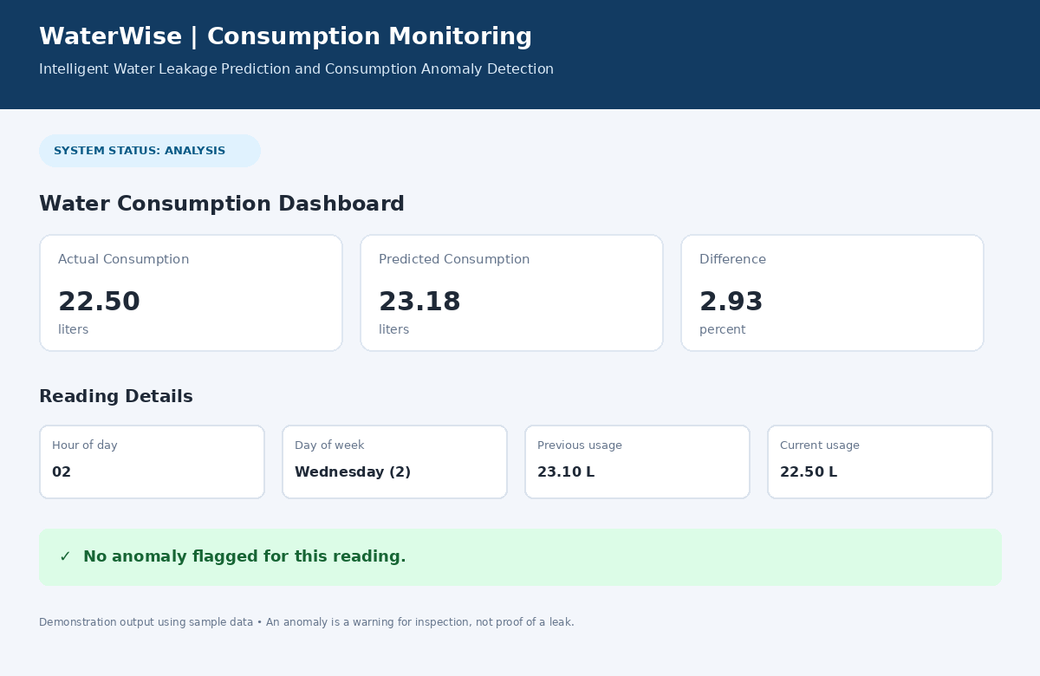
Fig. 3: Normal reading with no anomaly flagged.
Fig. 4: Unusual consumption warning recommending meter and plumbing inspection.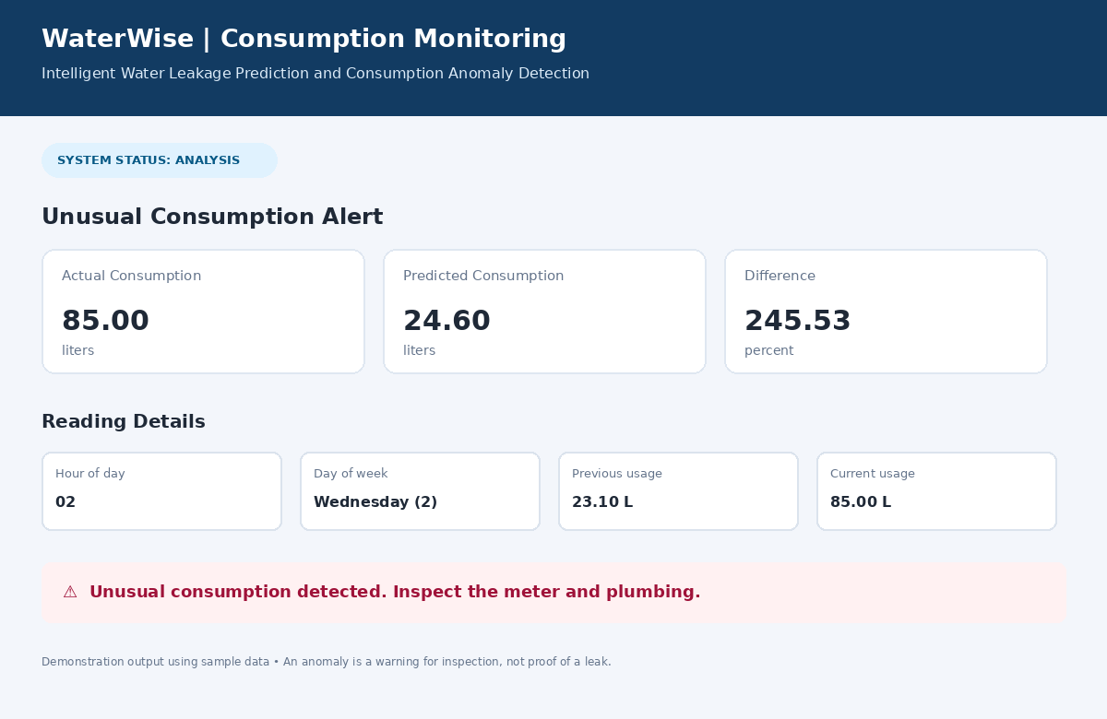
Fig. 5: Model evaluation output showing MAE and RMSE from the demonstration dataset.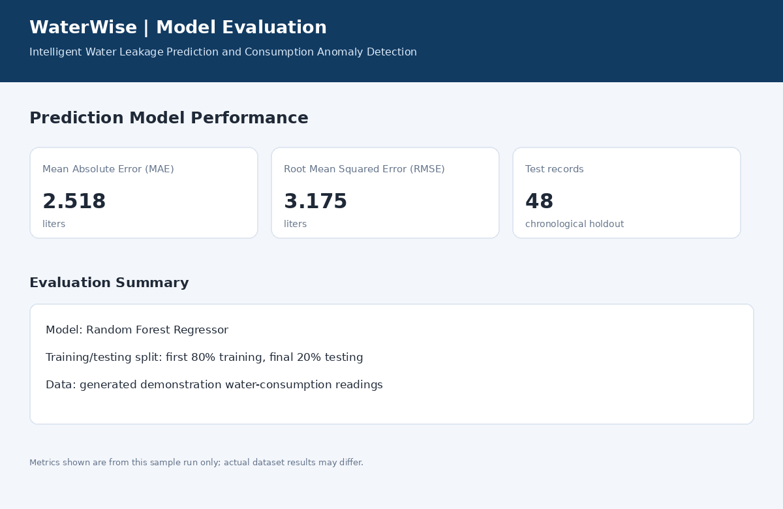

Evaluation
For consumption prediction, Mean Absolute Error (MAE) and Root Mean Squared Error (RMSE) can be calculated on a held-out chronological test set. Lower values generally indicate predictions closer to the observed readings, in the units of the consumption column. For anomaly detection, review flagged readings against verified events or manually inspected records. If labelled examples of leaks are available, precision, recall, F1-score, and a confusion matrix can also be reported.
Do not enter invented accuracy, precision, or other performance values in the final report. Record the actual metrics produced by running the program on the selected dataset. The Isolation Forest contamination setting is an initial configuration and should be tuned to suit the real data.

Result
The proposed Intelligent Water Leakage Prediction and Consumption Anomaly Detection system uses machine learning to estimate expected water consumption and flag unusual usage patterns. The Random Forest regression model provides a predicted consumption value, while the Isolation Forest model identifies patterns that may require further inspection. A Flask-based interface can present the results in an accessible form for users. Actual performance depends on the quality, quantity, and representativeness of the collected data. The system is intended to support early investigation of possible leakage; flagged readings should be verified by checking the meter and plumbing.

Conclusion
This project demonstrates how machine learning can be applied to water-use monitoring. By combining consumption prediction with anomaly detection, it can help users notice unusual usage earlier than manual observation alone. Future improvements may include real-time flow-sensor integration, SMS or email alerts, historical graphs, a SQLite database, and models trained on verified leak and non-leak examples.

